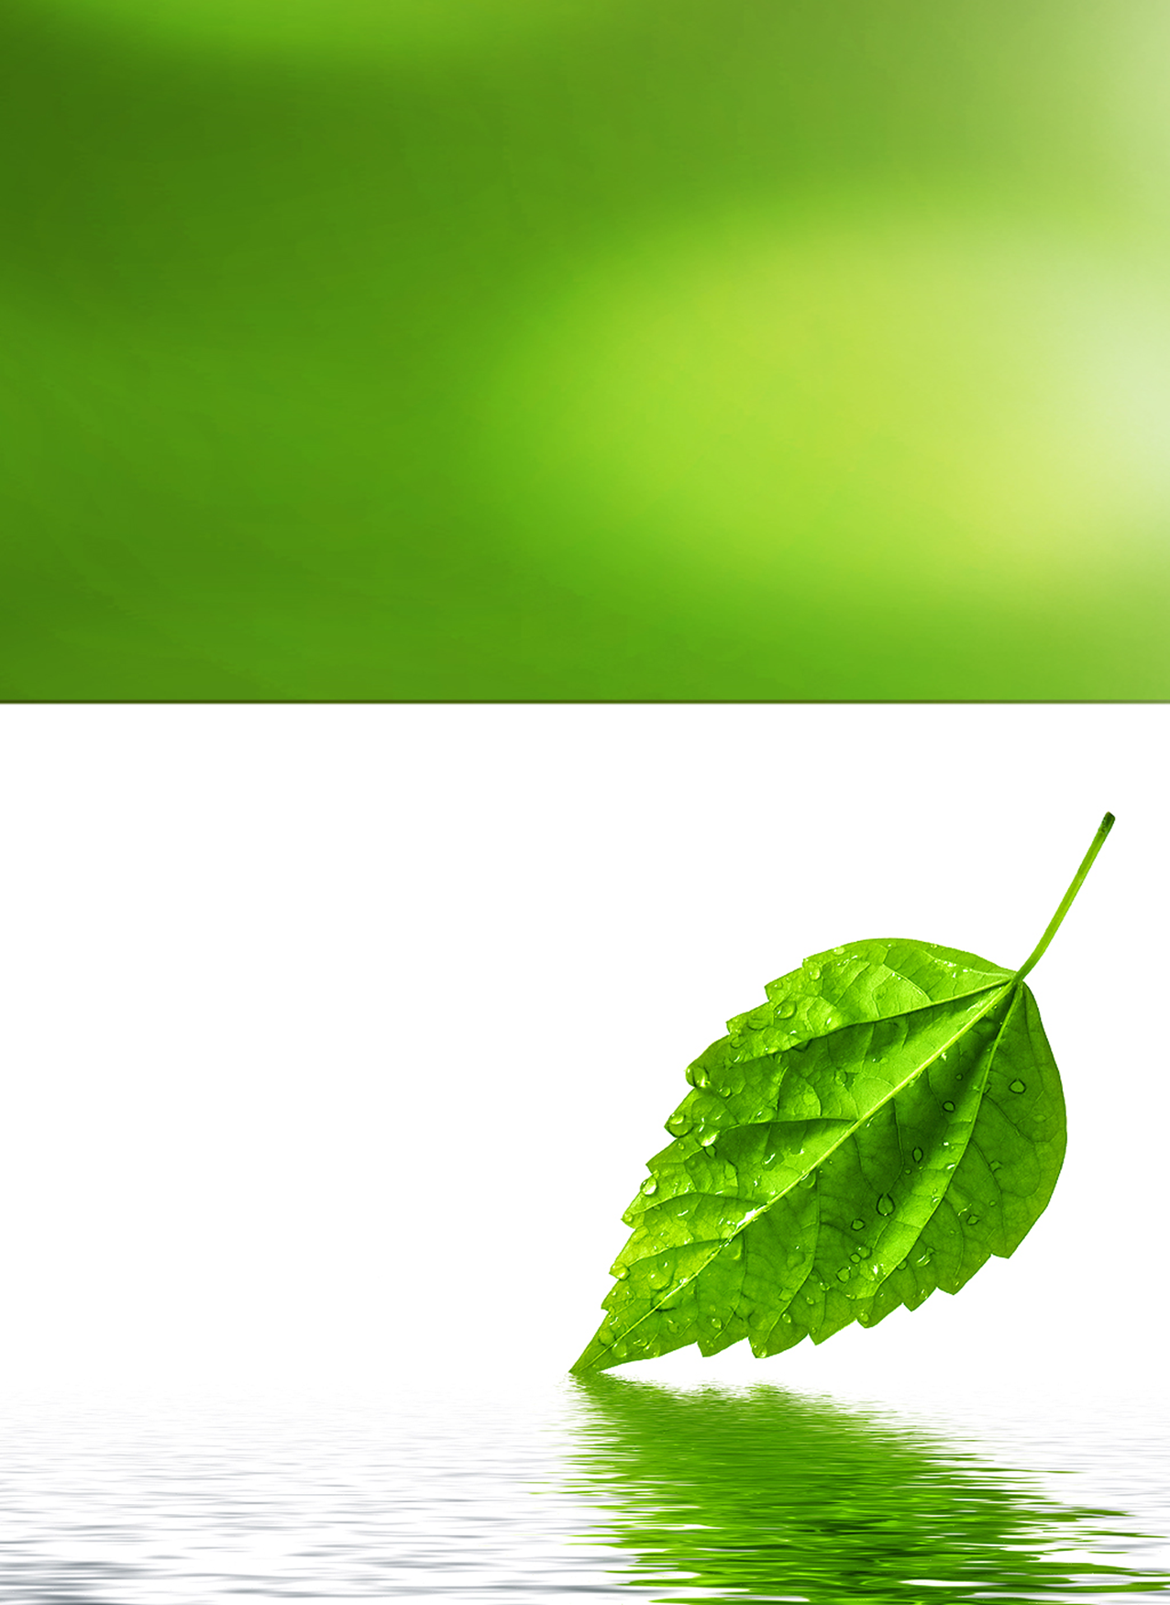

Stocked Items

Antioxidants & CoEnzymes • Calcium • Cosmetics/Lotions • Diet & Weight Loss • Digestive Aid • Gummies • Heart Health and Fish Oil Concentrates • Herbs, Herbal Formulas • Joint Health, Mobility, Anti-Inflammation • Melatonin • Men's Health • Multi-Vitamins • Minerals • Specialty Products • Sports Nutrition • Vitamins • Women's Health

|  |  |  |  |
| --- | --- | --- | --- |
| Antioxidants and CoEnzymes | | | |
| Item | Product Name | Size | Price |
| 379 | Acai 500mg | 60 Capsules | ** |
| 451 | Cell Protector | 60 Capsules | ** |
| 546 | Co-Enzyme Q10 30mg | 30 Softgels | ** |
| 547 | Co-Enzyme Q10 75mg | 30 Softgels | ** |
| 550 | Co-Enzyme Q10 100mg | 30 Softgels | ** |
| 109 | Flu Guard | 60 Capsules | ** |
| 376 | Goji 500mg | 60 Capsules | ** |
| 377 | Resveratrol 250mg | 60 Capsules | ** |
| Calcium | | | |
| Item | Product Name | Size | Price |
| 649 | Calcium 600mg with Vitamin D 400iu | 90 Tablets | ** |
| 670 | Calcium Magnesium Zinc Vitamin D | 100 Tablets | ** |
| 630 | Calcium Citrate with Vitamin D (Compare to Citrical) | 60 Tablets | ** |
| 660 | Calcium , Vitamin D, Vitamin K-2 | 16 ounces | ** |
| 651 | Liquid Calcium 1200 plus Vitamin D 1000 IU | 60 Softgels | ** |
| Cosmetics/Lotions | | | |
| Item | Product Name | Size | Price |
| 979 | Aloe Vera Lotion with Vitamin E | 60 Capsules | ** |
| 509 | Collagen Powder | 177 Grams | ** |
| 419 | Collagen 6000 with Biotin and Hyaluronic Acid | 16 Fl. oz | ** |
| 495 | Lightener Spot Reducer | 1.7 Ounces | ** |
| 502 | Collagen Face Cream with Hyaluronic Acid | 1.7 Ounces | ** |
| 504 | Collagen with Hyaluronic Acid | 60 Capsules | ** |
| 500 | Pain Cream | 4 oz. | ** |
| 498 | Marine Collagen with NanoTechnology Clinically Tested | 60 Capsules | ** |
| Diet and Weight Loss | | | |
| Item | Product Name | Size | Price |
| 390 | Coconut Oil Organic | 90 Softgels | ** |
| 814 | Fat Blocker, Sugar Blocker | 90 capsules | ** |
| 969 | Chitosan Ultra Fat Absorber Liposan | 60 Capsules | ** |
| 8179 | CLA Conjugated Linoleic Acid | 90 Softgels | ** |
| 935 | Green Tea 500 mg | 60 capsules | ** |
| 936 | Green Coffee Bean 50% | 60 Capsules | ** |
| 940 | Garcinia Cambogia | 60 Capsules | ** |
| 971 | Grapefruit Diet | 120 Tablets | ** |
| 811 | Hoodia+Green tea Super Weight Lost | 60 capsules | ** |
| 819 | Thermogentic formula | 90 capsules | ** |
| Digestive Aid and Gut Health | | | |
| Item | Product Name | Size | Price |
| 959 | South African Aloe Ferox | 60 Capsules | ** |
| 960 | Aloe Vera 5000mg | 60 Softgels | ** |
| 955 | Cascara Sagrada 450mg | 60 Capsules | ** |
| 961 | Colon Detox 14 X Colon Cleanser | 100 Capsules | ** |
| 962 | Digetox | 60 Capsules | ** |
| 977 | Digetox-5 Probiotic and Enzyme Formula | 60 Capsules | ** |
| 218 | Linaza Bags | 15 Ounces | ** |
| 219 | Linaza | 90 capsules | ** |
| 978 | Probiotic Acidophilus | 100 Softgels | ** |
| Gummies | | | |
| Item | Product Name | Size | Price |
| 519 | Elderberry Gummy | 60 gummies | ** |
| 520 | CBD Gummy | 60 gummies | ** |
| 513 | Kids Omega and DHA All Natural No Preservatives Gummy | 60 Gummies | ** |
| 516 | Kids Multivitamin All Natural No Preservatives Gummy | 60 Gummies | ** |
| Heart Health and Fish Oil Concentrates | | | |
| Item | Product Name | Size | Price |
| 980 | Carnitine & CoQ10 | 30 Softgels | ** |
| 102 | Cod Liver Oil with Vitamin A,D, and Omega-3 | 100 Softgels | ** |
| 214 | Enteric Coated Omega-3 1000mg | 100 Softgels | ** |
| 220 | Nuero IQ with DHA | 60 Softgels | ** |
| 215 | Omega-3 1000 180 EPA / 120 DHA | 100 Softgels | ** |
| 216 | Super Omega 3 300 EPA / 200 DHA | 90 Softgels | ** |
| 217 | Triple Omega 3 6 9 | 90 Softgels | ** |
| 221 | Triple Omega Flaxseed Primrose Oil and Fish Oil Formula | 90 Softgels | ** |
| 900 | Odorless Garlic 2000mg | 60 Softgels | ** |
| Herbs, Herbal Formulas | | | |
| Item | Product Name | Size | Price |
| 731 | Anamu 625mg | 100 Capsules | ** |
| 581 | Anamu Llanten 1200 | 100 Capsules | ** |
| 375 | Cranberry Fruit Concentrate | 60 Softgels | ** |
| 930 | Ginkgo Biloba 24:1 Extract 60mg | 100 Capsules | ** |
| 934 | Ginkgo Biloba 24:1 Extract 120mg | 60 Capsules | ** |
| 932 | Ginkgo and Ginseng | 60 Tablets | ** |
| 809 | Ginseng G450 (Panax Ginseng, American Ginseng, Siberian Mix) | 100 Capsu | ** |
| 810 | Korean Ginseng G520 | 100 Capsules | ** |
| 580 | Graviola 400mg - Anamu 100 mg | 100 Capsules | ** |
| 695 | Fenugreek | 60 Capsules | ** |
| Herbs, Herbal Formulas (Continued) | | | |
| Item | Product Name | Size | Price |
| 852 | Royal Jelly 100mg | 60 Sofgels | ** |
| 702 | Spirulina 500mg | 60 Tablets | ** |
| Joint Health, Mobility, Anti-Inflammation | | | |
| Item | Product Name | Size | Price |
| 118 | Alevitor Plus | 90 Capsules | ** |
| 129 | Alevitor Liquid Glucosamine, Chondroitin, and MSM | 16 Fl. oz | ** |
| 133 | CurQLife® Free Curcumin Clinically Tested | 60 Sofgels | ** |
| 134 | CurQLife® Plus Boswellia Patented Formula | 60 Capsules | ** |
| 121 | Glucosamine Chondroitin Hyaluronic Acid | 60 Tablets | ** |
| 120 | Glucosamine Chondroitin Boswellia | 60 Tablets | ** |
| 116 | Glucosamine Chondroitin MSM 1500mg | 60 Tablets | ** |
| 123 | Vegetarian Glucosamine, Chondroitin, Patented CurQLife® | 60 Capsules | ** |
| 125 | HG Fusion Collagen Complex, Glucosamine and MSM | 60 Capsules | ** |
| 130 | HG Fusion Advanced (Joint Formula) | 60 Capsules | ** |
| 117 | Triple Strength Glucosamine Chondroitin MSM with CurQLife® | 60 Tablets | ** |
| 210 | Shark Cartilage 750mg | 100 Capsules | ** |
| Melatonin | | | |
| Item | Product Name | Size | Price |
| 800 | Melatonin 3mg with B6 Mint Flavor | 60 Tablets | ** |
| 795 | Melatonin 5mg Sublingual Cherry Flavor | 60 Sofgels | ** |
| 797 | Melatonin 5 mg Liquid | 60 Sofgels | ** |
| 803 | Melatonin 5mg with B6 Mint Flavor | 60 Tablets | ** |
| 798 | Melatonin 10mg | 60 Capsules | ** |
| 796 | Sleep Formula with Valerian Root | 60 Capsules | ** |
| Men's Health | | | |
| Item | Product Name | Size | Price |
| 400 | Andro-T Testosterone Booster | 100 Capsules | ** |
| 385 | Bladder Care Clinically Studied | 60 Capsules | ** |
| 399 | NO3 Booster with Bulgarian Tribulus | 60 Capsules | ** |
| 950 | Prostate Plus Saw Palmetto | 60 Capsules | ** |
| 945 | Saw Palmetto 500mg | 100 Capsules | ** |
| 825 | Tribulus 500 mg | 60 Capsules | ** |
| 965 | Sex Fuel for Men | 60 Capsules | ** |
| 964 | Viax for Sexual Health | 20 Capsules | ** |
| Multi-Vitamins | | | |
| Item | Product Name | Size | Price |
| 555 | Multi-Vitamin (adult) | 100 Tablets | ** |
| 560 | Multi-Vitamin (seniors) | 100 Tablets | ** |
| Multi-Vitamins (Continued) | | | |
| Item | Product Name | Size | Price |
| 5703 | Natural Swiss Formula | 30 Softgels | ** |
| 570 | Natural Swiss Formula | 100 Softgels | ** |
| Minerals | | | |
| Item | Product Name | Size | Price |
| 703 | Chromium Picolinate 1000 mcg plus Glucomannan | 100 Capsules | ** |
| 330 | Folic Acid 400mg | 100 Tablet | ** |
| 705 | Magnesium 500mg | 100 Tablet | ** |
| 680 | Potassium Gluconate 595 mg | 100 Tablet | ** |
| 685 | Selenium 50 mcg | 100 Tablet | ** |
| 676 | Zinc Gluconate 50 mg | 100 Tablet | ** |
| Specialty Products | | | |
| Item | Product Name | Size | Price |
| 386 | Blood Pressure Control | 60 Capsules | ** |
| 234 | CurQLife Vision (Curcumin Vision Formula) | 60 Capsules | ** |
| 150 | Glucose Care | 60 Capsules | ** |
| 155 | Glucose Support | 60 Capsules | ** |
| 559 | Liver Care with CurQLife® | 60 Capsules | ** |
| 384 | Liver Max L-Arginine Milk Thistle Anamu | 60 Capsules | ** |
| 383 | Memory Control | 60 Capsules | ** |
| 816 | Soya Lecithin | 100 Softgels | ** |
| Sports Nutrition | | | |
| Item | Product Name | Size | Price |
| 853 | 7 Keto DHEA 25mg | 60 Capsules | ** |
| 854 | 7 Keto DHEA 50mg | 60 Capsules | ** |
| 856 | 7 Keto DHEA 100mg | 60 Capsules | ** |
| 972 | Amino 4890 | 90 Tablets | ** |
| 968 | Amino Muscle | 90 Tablets | ** |
| 990 | BCAA | 90 capsules |  |
| 985 | Cardi Slim | 16 Fl. Oz. | ** |
| 709 | Creatine | 300 Grams | ** |
| 708 | Creatine Capsules | 120 Capsules | ** |
| 850 | DHEA 25mg | 60 Capsules | ** |
| 851 | DHEA 50mg | 60 Capsules | ** |
| 855 | DHEA 100mg | 60 Capsules | ** |
| 826 | L-Arginine 500mg | 60 Capsules | ** |
| 967 | L-Carnitine 500mg | 30 Capsules | ** |
| 980 | L-Carnitine 500mg Plus CoQ10 30mg | 60 Capsules | ** |
| Item | Product Name | Size | Price |
| 986 | L-Carnitine Liquid 1000mg | 16 Fl. oz | ** |
| 992 | L-Carnitine Liquid 3000mg and Apple Cider Vinegar | 16 Fl. oz | ** |
| 984 | L-Carnitine Liquid 5000mg | 16 Fl. oz | ** |
| 997 | L-Glutamine 500mg | 60 Capsules | ** |
| 399 | NO Booster Bulgarian Tribulus | 60 Capsules | ** |
| 991 | Pre-workout formula | 430 Grams | ** |
| 989 | OptiNOs® Clinically Tested Plus L-Citrulline & L-Arginine | 90 Capsules | ** |
| 828 | OptiNOs® tablet with L-Arginine 1000mg per tablet | 100 tablets | ** |
| 987 | L-Carnitine Liquid 3000mg + 5 Grams of Collagen | 16 Fl. oz | ** |
| 925 | Tribulus 500mg | 60 Capsules | ** |
| 990 | Whey Protein | 2 lbs. | ** |
| 994 | Whey Protien with Digestive Enzymes and Collagen | 2 lbs. | ** |
| Vitamins | | | |
| Item | Product Name | Size | Price |
| 311 | Liquid B-Complex | 60 Softgels | ** |
| 340 | Natural C 500mg with Rose Hips | 100 Tablets | ** |
| 350 | Natural C 1000mg with Rose Hips | 100 Tablets | ** |
| 435 | Natural E 400IU D-Alpha 100% Pure | 100 softgels | ** |
| 300 | Niacin 500mg Flush Free | 60 Capsules | ** |
| 105 | Vitamin A 10,000 IU | 100 Softgels | ** |
| 100 | Vitamin A 25,000 IU | 100 Softgels | ** |
| 321 | Vitamin B-12 1000mg Sublingual | 60 Tablets | ** |
| 339 | Vitamin C 500mg | 100 Tablets | ** |
| 340 | Vitamin C 500mg with Rose Hips | 100 Tablets | ** |
| 349 | Vitamin C 1000mg | 100 Tablets | ** |
| 349 | Vitamin C 1000mg | 100 Tablets | ** |
| 365 | Vitamin C 1000mg with Rose Hipe, Timed Release | 60 Tablets | ** |
| 106 | Vitamin D 1000 IU | 100 Softgels | ** |
| 107 | Vitamin D 2000 IU | 100 Softgels | ** |
| 108 | Vitamin D 5000 IU | 100 Softgels | ** |
| 104 | Vitamin D 10,000 IU | 50 Softgels | ** |
| 333 | Vitamin D 2000 IU and Vitamin K 2 180 mcg | 60 Softgels | ** |
| 450 | Natural E 400IU Dl-Alpha | 100 softgels | ** |
| 491 | Vitamin E 1000iu DL-Alpha | 100 Softgels | ** |
| 4912 | Vitamin E 1000iu DL-Alpha | 50 Softgels | ** |
| Women's Health | | | |
| Item | Product Name | Size | Price |
| 326 | Biotin 2500 mcg | 60 Tablets | ** |
| 327 | Biotin 10,000 mcg | 60 Tablets | ** |
| 385 | Bladder Care | 60 Capsules | ** |
| 375 | Cranberry Fruit Concentrate with Vitamin C | 60 Softgels | ** |
| 646 | Evening Primrose Oil (EPO) 1000mg | 60 Softgels | ** |
| 505 | Hair Skin Nails with Keratin and Biotin | 60 Tablets | ** |
| 507 | Menopause Formula Clinically Studied | 120 Capsules | ** |
| 506 | Prenatal Vitamins | 60 Tablets | ** |
| 600 | Prenatal Plus dha | 60 Softgels | ** |